Association between in-ICU red blood cells transfusion and one-year mortality in ICU survivors

Imke Mayer,Paul Roussel, Antoine Kimmoun, Thomas Merkling,Kevin Duarte, Julie Josse

# Attention: the following code doesn’t work without the original data. This code is provided to present what has been performed.

# Methods

## Statistical analysis

Patients were separated into two groups: those who received RBC transfusion (i.e.: at least one unit of packed RBC) during their ICU stay, and those who did not. Survival was observed over a period of one year following ICU discharge. Of note, to assess the impact of transfusion in patient selection at discharge, one-year survival curves were additionally also drawn from admission to ICU with the whole FROG cohort population.

### Primary outcomes

The primary outcome was one-year survival after ICU discharge. The average treatment effect of RBC transfusion on survival was estimated from the survival curves of patients with and without RBC transfusion, from the associated hazard ratio, and from the difference in restricted mean survival times (RMST). The latter corresponds to the average number of days gained or lost in terms of overall one-year survival after ICU discharge between patients transfused and not transfused during their ICU stay. The confidence intervals associated with these estimated values were computed from 100 bootstrap samples. Data description Data were expressed as median (inter-quartile range, IQR), mean ± standard deviation (SD), or number (percentage). Numerical data were compared using t-test or Wilcoxon rank test, while categorical variables were compared using χ2 or Fischer’s test, as appropriate. Repeated measures of continuous variables were handled by a linear mixed model tested with Kenward-Roger’s F tests.

### Management of missing data

Two approaches were used for handling the missing values: parametric with multiple imputations by chained equations (MICE), and non-parametric with random forest-missingness incorporated in attributes (MIA). Details of the two methods are provided in the Additional Data Supplement Text. Number of missing values per variable was also added in Figure E2.

### Models

#### Semi-parametric and non-parametric approaches to estimate models.

Two different approaches were considered to estimate the effect of RBC transfusion on one-year mortality: a semi-parametric approach and a non-parametric approach. In the semi-parametric approach, we used Cox models to model the survival and the censoring. Treatment allocation was modelled with a propensity score calculated from a logistic regression. In the non-parametric approach, we modelled with random survival forests the survival, the censoring, and the treatment allocation. Under these semi-parametric and non-parametric approaches, two estimators (see estimators performed below) were applied to assess the study’s primary outcomes based on models in which identification of confounding factors is required.

#### Confounding variables selection.

A three round Delphi method including experts in critical care and transfusion was used to identify the confounding variables necessary to build the different models. Figure E3 in the additional data supplement figure shows the causal inference diagram applied in a directed acyclic graph, differentiating variables assessed as predictors of the outcome but unrelated to the treatment assignment and the variables assessed as predictors of both treatment and outcome.

### Causal inference estimators

#### Estimator performed to draw survival curves

The unweighted curves were estimated with the Kaplan Meier estimator, the unweighted hazard ratio was estimated with a Cox regression with only the transfusion status as a variable. The weighted survival curves were built with the non-parametric doubly robust estimator, i.e.: augmented inverse probability of treatment weighting - augmented inverse probability of censoring weighting (AIPTW-AIPCW using survival and random forests-MIA method for management of missing values, see Additional Data Supplement Text). The weighted hazard ratio was computed from the weighted survival curves by averaging the hazard ratio at each time point. This estimator was calculated in our main population of interest: ICU-survivors from ICU-discharge but also, to ensure that the result was not driven by patient’s ICU stay, in the whole initial population (including ICU-survivors and non-survivors) from ICU admission.

#### Estimators performed

The three following causal inference estimators were performed to calculate the RMST: 1) the unweighted estimation with no adjustment, then, in parametric and non-parametric approaches of missing values: 2) the inverse probability of treatment weighting with the Kaplan Meier estimator (IPTW), 3) the AIPTW-AIPCW. Details of each estimator are provided in the Additional Data Supplement Text.

#### Exploratory analysis

Except for the packed red blood cells unit number threshold associated with one-year mortality (see below), all exploratory analyses were performed using parametric (with MICE) imputed FROG-ICU cohort. Packed red blood cells threshold With non-imputed data, we looked for the number of the packed RBC units for which there was a maximal increase in one-year mortality after ICU discharge. First, the log linearity assumption was checked using the restricted cubic spline method. Given the lack of log linearity, number of packed RBC units transfused has been dichotomized according to an optimal level determined using the most significant p-value from the log rank test. Subsequently, this threshold has been validated using a univariate Cox model.

A two-tailed p-value of less than 0.05 was considered significant. Statistical analyses were performed using R v3.6.3 (R Foundation for Statistical Computing, Vienna, Austria).

# Packages

# Load

# Systematic preprocessing

## For ICU survivors from discharge

## For whole population from admission

# Results

## *Table 1 : Description of characteristics at baseline in the non-weighted population*

table1

Table 1:Description of the total ICU population at discharge and according to RBC transfusion during ICU stay

| variable | N available total population | Total population | N available no transfusion group | No transfusion group | N available transfusion group | Transfusion group | p-value |
| --- | --- | --- | --- | --- | --- | --- | --- |
| Age (years) | 1551 | 61 (49 - 73) | 892 | 60 (48 - 71) | 659 | 63 (51 - 74) | 0.0003 |
| Female gender (%) | 1551 | 566 (36 %) | 892 | 314 (35 %) | 659 | 252 (38 %) | 0.22 |
| BMI(Kg/m^2) | 968 | 26 (23 - 31) | 522 | 26 (23 - 31) | 446 | 27 (23 - 30) | 0.38 |
| Charlson score | 1551 | 1 (0 - 2) | 892 | 0 (0 - 2) | 659 | 1 (0 - 2) | <0.0001 |
| Hypertension | 1550 | 634 (41 %) | 892 | 337 (38 %) | 658 | 297 (45 %) | 0.004 |
| Coronary artery disease | 1550 | 123 (8 %) | 892 | 49 (5 %) | 658 | 74 (11 %) | <0.0001 |
| Chronic heart failure | 1550 | 106 (7 %) | 892 | 54 (6 %) | 658 | 52 (8 %) | 0.15 |
| Diabetes mellitus | 1550 | 271 (17 %) | 892 | 143 (16 %) | 658 | 128 (19 %) | 0.080 |
| Chronic obstructive pulmonary disease | 1550 | 171 (11 %) | 892 | 102 (11 %) | 658 | 69 (10 %) | 0.56 |
| Chronic renal disease | 1550 | 162 (10 %) | 892 | 58 (7 %) | 658 | 104 (16 %) | <0.0001 |
| Chronic liver disease | 1550 | 98 (6 %) | 892 | 49 (5 %) | 658 | 49 (7 %) | 0.12 |
| Active or recent malignant Cancer | 1550 | 186 (12 %) | 892 | 77 (9 %) | 658 | 109 (17 %) | <0.0001 |
| Cardiac causes of admission | 1551 | 221 (14 %) | 892 | 150 (17 %) | 659 | 71 (11 %) | <0.0001 |
| Hemorrhagic shock |  | 83 (5 %) |  | 10 (1 %) |  | 73 (11 %) |  |
| Acute respiratory failure |  | 299 (19 %) |  | 204 (23 %) |  | 95 (14 %) |  |
| Neurologic causes of admission |  | 240 (15 %) |  | 200 (22 %) |  | 40 (6 %) |  |
| Others |  | 96 (6 %) |  | 45 (5 %) |  | 51 (8 %) |  |
| Polytrauma |  | 86 (6 %) |  | 38 (4 %) |  | 48 (7 %) |  |
| Post operative-room |  | 156 (10 %) |  | 73 (8 %) |  | 83 (13 %) |  |
| Sepsis |  | 370 (24 %) |  | 172 (19 %) |  | 198 (30 %) |  |
| SOFA score | 1146 | 7 (4 - 10) | 633 | 7 (4 - 10) | 513 | 8 (5 - 11) | <0.0001 |
| SAPS II score | 1550 | 46 (34 - 60) | 891 | 46 (34 - 59) | 659 | 46 (35 - 61) | 0.085 |
| Renal replacement therapy | 1551 | 283 (18 %) | 892 | 102 (11 %) | 659 | 181 (27 %) | <0.0001 |
| Red blood transfusion | 1551 | 659 (42 %) | 892 | 0 (0 %) | 659 | 659 (100 %) | <0.0001 |
| Platelets transfusion | 1551 | 223 (14 %) | 892 | 20 (2 %) | 659 | 203 (31 %) | <0.0001 |
| Hemoglobin at discharge (g/dl) | 1350 | 10.0 (9.0 - 11.2) | 751 | 10.4 (9.3 - 11.7) | 599 | 9.6 (8.6 - 10.6) | <0.0001 |
| Number of red blood transfusions | 1551 | 0 (0 - 3) | 892 | 0 (0 - 0) | 659 | 4 (2 - 7) | <0.0001 |
| Systolic blood pressure at discharge (mmHg) | 1351 | 125 (111 - 139) | 759 | 124 (111 - 138) | 592 | 125 (111 - 140) | 0.36 |
| Diastolic blood pressure at discharge (mmHg) | 1292 | 68 (59 - 77) | 712 | 69 (60 - 77) | 580 | 67 (58 - 76) | 0.001 |
| Heart rate at discharge (bpm) | 1336 | 90 (79 - 101) | 746 | 88 (78 - 99) | 590 | 92 (80 - 103) | 0.001 |
| Creatinine at discharge (micromol/l) | 1494 | 66 (51 - 96) | 849 | 64 (51 - 83) | 645 | 73 (52 - 118) | <0.0001 |
| Platelets at discharge (/ml) | 1342 | 293000 (184000 - 434000) | 742 | 293000 (188000 - 432000) | 600 | 292500 (174000 - 436000) | 0.24 |
| lactate at discharge (mmol/l) | 645 | 1.0 (0.7 - 1.3) | 345 | 0.9 (0.7 - 1.3) | 300 | 1.1 (0.8 - 1.4) | <0.0001 |
| Length of stay in ICU (days) | 1551 | 12 (7 - 21) | 892 | 10 (6 - 16) | 659 | 16 (9 - 27) | <0.0001 |
| Length of stay at hospital (days) | 1550 | 26 (15 - 44) | 891 | 21 (13 - 37) | 659 | 32 (21 - 53) | <0.0001 |
| Non-survivor at one-year post-discharge | 1551 | 312 (20 %) | 892 | 141 (16 %) | 659 | 171 (26 %) | <0.0001 |

## *The different methods:*

#### For estimating the effect of the treatment, there are three families of methods:

First, a method that models the response of the covariates on the allocation of the treatment and on the censoring mechanism. this is the method using propensity score: Inverse probability weighting (IPW) method.

Second, a model that models the survival time conditional on the covariates: G-formula

Third, methods that combine the first two models. These methods are robust to mis-specification of one of the two previous models: Augmented Inverse probability weighting (AIPW)}.

## *Figure 1: One-year survival from discharge according to transfusion status in non-weighted and weighted population*

Fig2

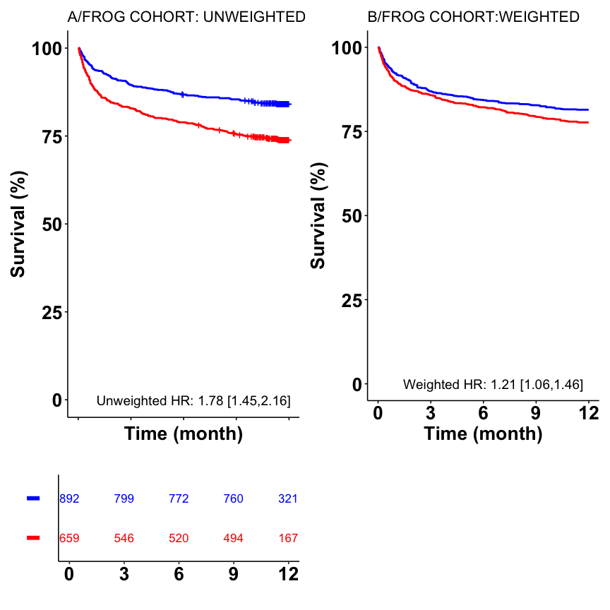

## *Figure 2: Average treatment effect of the restricted survival time for the first 365 days after discharge*

The survival curve and the censoring mechanism are estimated by a cox model with the covariates resposible to the outcome. The propensity score is estimated by a forest regression with the confounding variables. The missing data is handled by multiple imputation (5 iterations). The multiple imputation model include the outcome and all variables to be considered in the different models. The variance is obtained with bootstrapping (100 iterations)

Fig2

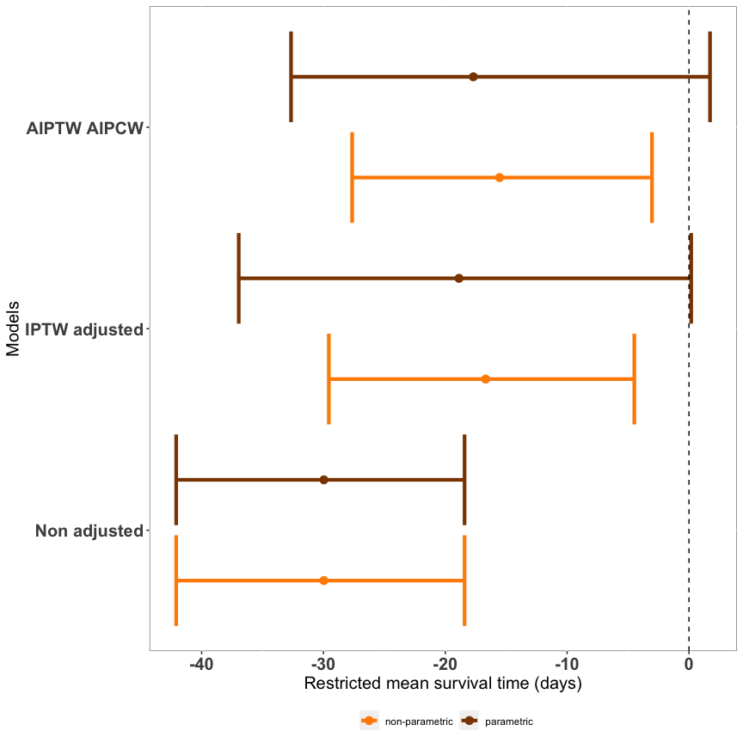

## *Figure E1: Summary of the statistical analysis performed. MICE: multiple imputations by chained equations RF-MIA: random forest-missingness incorporated in attributes, AIPTW-AIPCW: augmented inverse probability of treatment weighting - augmented inverse probability of censoring weighting, IPTW: inverse probability of treatment weighting.*



## *Figure E2: Absolute number of missing values in patients discharged alive in the FROG ICU cohort (n=1551). A: admission, CRP: C reactive protein, CV: cardiovascular, D: discharge, DBP: diastolic blood pressure, eGFR: glomerular filtration rate, I: inclusion, IL6: interleukin 6, LFABP: liver fatty acid binding protein (log), NGAL: neutrophil gelatinase associated lipocalin, p: plasma, PT: prothrombin time, RBC: red blood cells, RRT: renal replacement therapy, SBP: systolic blood pressure.*

gg_miss_var(FigE2)

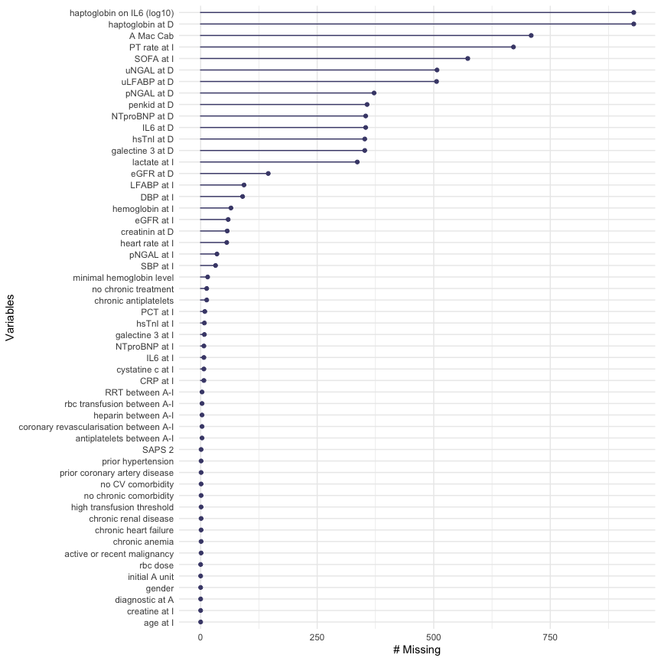

## *Figure E3: Directed acyclic diagram for variables associated with both the transfusion and the one-year mortality (red) and variables only associated with the outcome (blue). A, admission; I, Inclusion, A-I, Admission – Inclusion. DBP: diastolic blood pressure, eGFR: estimated glomerular filtration rate, RRT: renal replacement therapy, SAPS2: simplified acute physiology score II, SBP: systolic blood pressure, SOFA: sequential organ failure assessment*



## *Figure E4 : Flow chart*

FigE4

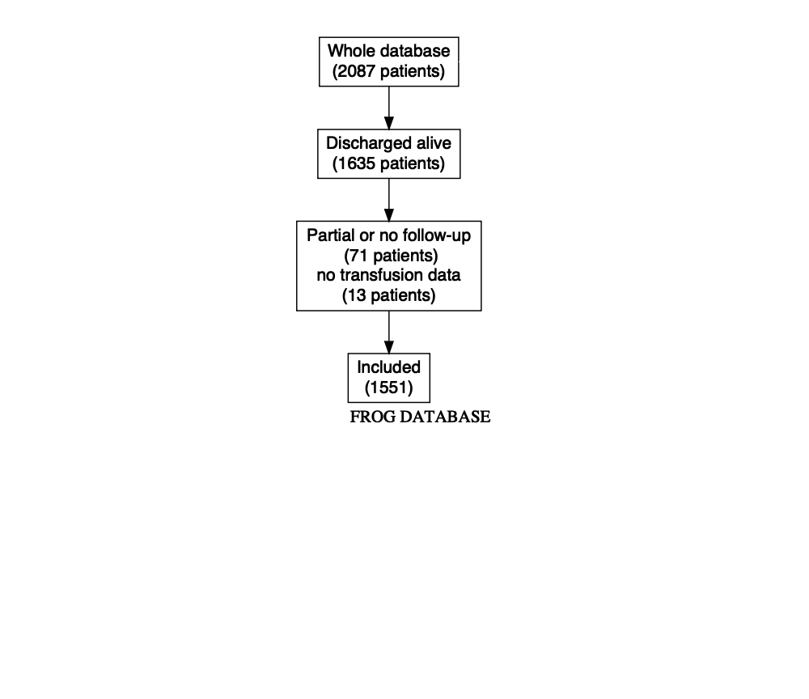

## *Figure E5: Timing of the first RBC transfusion from inclusion in the FROG-ICU cohort. Patients in whom the first transfusion was administered after day 25 are not represented on the Figure (n= 4 patients)*

FigE5

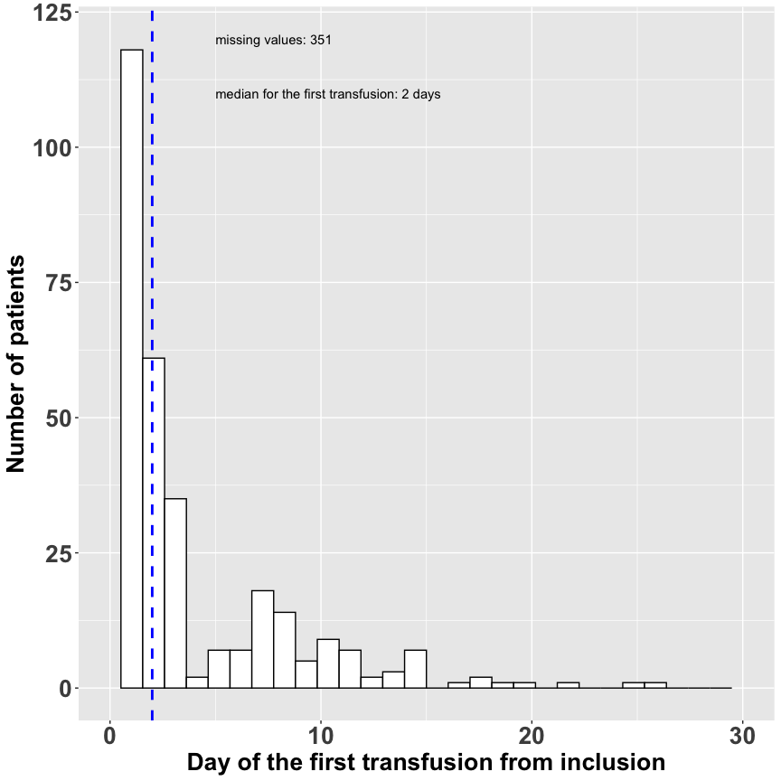

La médiane du délai d’inclusion transfusion est de 2 (1-6) jours.

ggsave("FIGURES/Figure E5.pdf", plot=FigE5, width = 15, height = 10, units = "cm",scale = 1.5, dpi = 300)

## *Figure E6: Lowest Hb values evolution from admission to discharge in the non-matched population according to transfusion status. Data were collected at admission, day 1 to 3 and then bi-weekly until discharge. P value represent the interaction between time points and transfusion status on Hb values*

FigE6

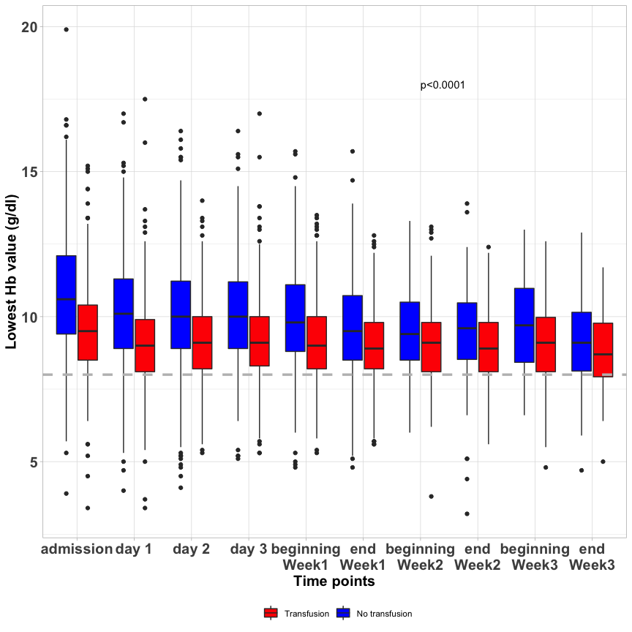

## *Figure E7: Probability to receive transfusion in the transfusion group and in the non-transfusion group in the FROG-ICU cohort. Panel A: The probability has been estimated according to a logistic regression with the baseline confounding variables excluding those impacting only the outcome (blue covariates of Figure E2). Panel B: The estimation of the probability has been done using random forests with all the confounding variables excluding those impacting only the outcome (blue covariates of Figure E2).*

FigE7<-FigE7a+FigE7b  
FigE7

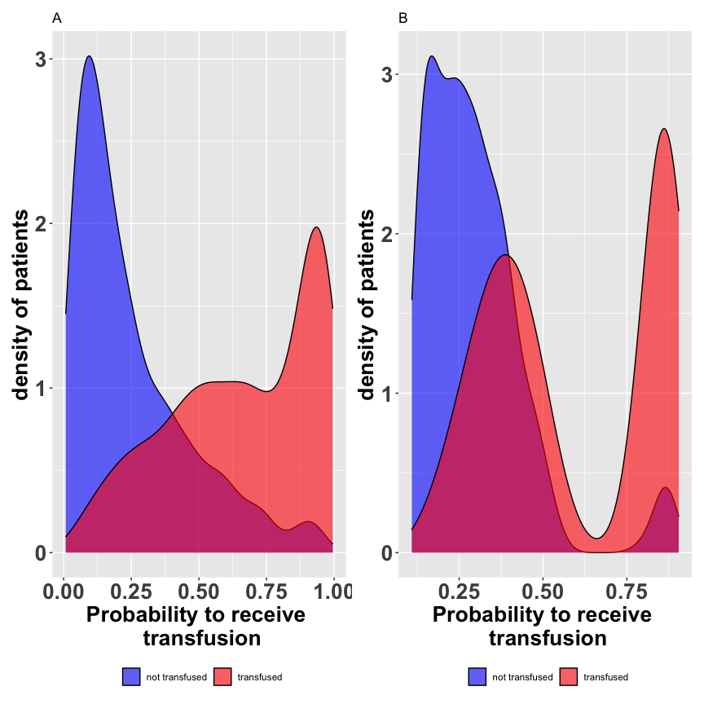

ggsave("FIGURES/Figure E7.pdf", plot=FigE7, width = 40, height = 20, units = "cm",scale = 1.2, dpi = 300)

## *Figure E8: Standardized mean difference of confounding variables for the unweighted population and the weighted population given the inverse probability weighting score in the FROG-ICU cohort. Confounding variables included variables at baseline associated to both transfusion prescription and outcome. I: inclusion; neuro: neurological failure; ARF: acute respiratory failure, PO: post-operative scheduled and unscheduled; CS: cardiogenic shock and cardiac arrest; SS: severe sepsis or septic shock; HS: hemorrhagic shock including trauma; others: acute liver failure, acute kidney failure, hypovolemic shock, anaphylactic shock, multiple organ failure, acute pancreatitis, metabolic; F: female; cv: cardiovascular, C-V: cardio-vascular, eGFR: glomerular filtration rate; PT: prothrombine time.*

FigE8

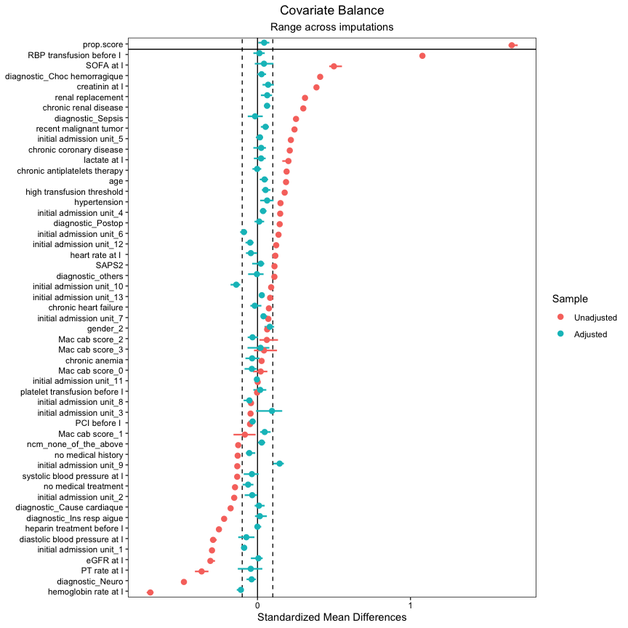

## *Figure E9: One-year survival from admission in the whole population of the FROG-ICU cohort PANEL A: Unweighted; PANEL B: Weighted. For the whole population sample size from 2087 patients,72 patients had no or partial follow up and 30 no transfusion data resulting in 1071 patients in the no transfusion group and 914 patients in the transfusion group.*

FigE9

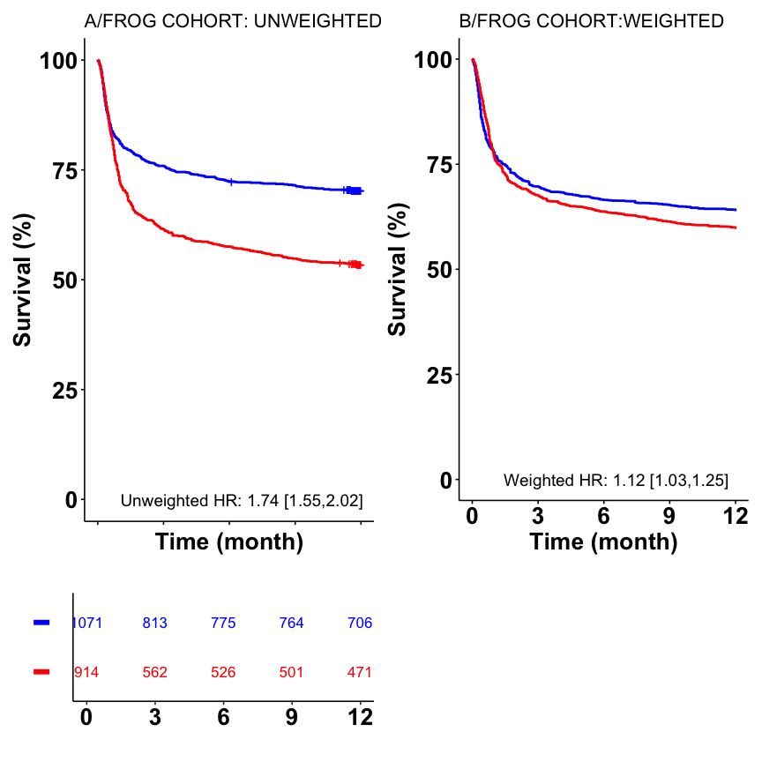

## *Figure E10: Sensitivity analysis for clinical variables according to parameters at discharge in the unweighted FROG-ICU cohort. Reference is no transfusion continuous variables were dichotomized according to median.*

RESULTATS<-read.csv2("DATA/resultats_figE10.csv")  
RESULTATS<-RESULTATS[,-1]  
  
pdf(file = "FIGURES/Figure E10.pdf", width = 13, height = 9, pointsize = 10)  
  
#schéma  
par(mar=c(3,17.5,3,5), mfrow=c(1,1))  
plot(RESULTATS$OR, RESULTATS$Ordre,bty="n",xlim=c(-8,15), ylim=c(1,10.5)  
, pch=c(15),cex=1.5,xaxt="n",yaxt="n",xlab="",ylab="", main="One-year mortality\n in patients receiving in-ICU transfusion. Clinical variables")  
#rajout des axes "sur mesure"  
axis(side=1,at=c(-1,1,5),labels=c("protector",1,"risk factor"),cex.axis=1.1, font=c(2,1,2))  
axis(side=2,at=RESULTATS$Ordre,labels=RESULTATS$Variable1,cex.axis=1.2,las=2, pos = c(-1))  
#ajouts des segments représentant les intervalles de confiance  
segments(x0=RESULTATS$OR, y0=RESULTATS$Ordre,x1=RESULTATS$CI2,lwd=2)  
segments(x0=RESULTATS$CI1, y0=RESULTATS$Ordre,x1=RESULTATS$OR,lwd=2)  
#trait de référence au niveau du 1  
abline(v=1,lty=2,lwd=2,col="grey")  
#ajout du texte créé plus haut OR[IC95]  
text(5, RESULTATS$Ordre,RESULTATS$OR_CI,pos=c(4.5),cex=1.2)  
text(5,10,"OR [95%CI]",pos=4,cex=1.2)  
text(10.5, RESULTATS$Ordre,RESULTATS$pval,pos=c(4.5),cex=1.2)  
text(10.5,10,"p interaction",pos=4,cex=1.2)  
  
#Ajouter fleche  
x0<-c(4,4)  
x1<- c(4.01,4.01)  
y0 <-c(9,9)  
y1 <-c(9,9)  
couleur<-c("black")  
arrows(x0,y0,x1,y1, code=2,lwd=2)  
  
x0<-c(4,4)  
x1<- c(4.01,4.01)  
y0 <-c(5,5)  
y1 <-c(5,5)  
couleur<-c("black")  
arrows(x0,y0,x1,y1, code=2,lwd=2)  
  
x0<-c(4,4)  
x1<- c(4.01,4.01)  
y0 <-c(4,4)  
y1 <-c(4,4)  
couleur<-c("black")  
arrows(x0,y0,x1,y1, code=2,lwd=2)  
  
dev.off()

quartz_off_screen   
 2

## *Figure E11: Sensitivity analysis for biomarkers variables according to parameters at discharge in the unweighted FROG-ICU cohort. Reference is no transfusion continuous variables were dichotomized according to median.*

RESULTATS<-read.csv2("DATA/resultats_figE11.csv")  
RESULTATS<-RESULTATS[,-1]  
  
pdf(file = "FIGURES/Figure E11.pdf", width = 13, height = 9, pointsize = 10)  
  
#schéma  
par(mar=c(3,17.5,3,5), mfrow=c(1,1))  
plot(RESULTATS$OR_2*3, RESULTATS$Ordre_2,bty="n",xlim=c(-8,15), ylim=c(1,10)  
, pch=c(15),cex=1,xaxt="n",yaxt="n",xlab="",ylab="", main="One-year mortality\n in patients receiving in-ICU transfusion. Biomarker variables")  
#rajout des axes "sur mesure"  
axis(side=1,at=c(1,4),labels=c(1,"risk factor"),cex.axis=0.5, font=c(2,1,2))  
axis(side=2,at=RESULTATS$Ordre_2,labels=RESULTATS$Variable1,cex.axis=1.2,las=2, pos = c(-1))  
#ajouts des segments représentant les intervalles de confiance  
segments(x0=RESULTATS$OR_2*3, y0=RESULTATS$Ordre,x1=RESULTATS$CI2_2*3,lwd=2)  
segments(x0=RESULTATS$CI1_2*3, y0=RESULTATS$Ordre,x1=RESULTATS$OR_2*3,lwd=2)  
#trait de référence au niveau du 1  
abline(v=1,lty=2,lwd=2,col="grey")  
#ajout du texte créé plus haut OR[IC95]  
text(5, RESULTATS$Ordre,RESULTATS$OR_CI_2,pos=c(4.5),cex=1.2)  
text(5,9.5,"OR [95%CI]",pos=4,cex=1.2)  
text(10.5, RESULTATS$Ordre,RESULTATS$pval_2,pos=c(4.5),cex=1.2)  
text(10.5,9.5,"p interaction",pos=4,cex=1.2)  
  
dev.off()

quartz_off_screen   
 2

## *Figure E12: Haptoglobine level normalized by IL6 level. panel A: in RBC transfusion vs RBC no transfusion, panel B: according to eGFR ranges (imputed population)*

FigE12

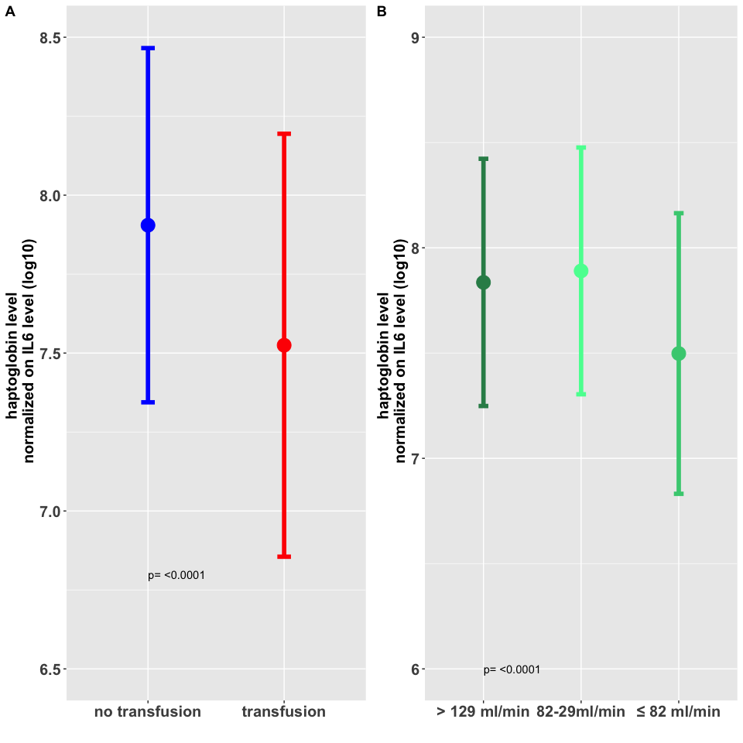

## *Figure E13: Hazard ratio of death according to the number of packed RBC administered during ICU stay in the unweighted FROG-ICU cohort.*

le seuil de CGR minimal evalué par la p value la plus grande du log rank test est 0 CGR dans la population totale

Au dela de 0 existe il un seuil ou la mortalité augmente?

Dans la population transfusée il n’y a pas d’association entre la mortalité et le nombre de CGRs transfusés

Dans la population globale, le premier culot augmente la mortalité de facon significative. Au dela d’un culot, il n’y a pas de sur-risque de mortalité ou la mortalité est identique.

RBP 1,2 ou >2

RBP 0 ou >2

RBP continu

RBP 0

RBP >0

AIC

2170.879

2170.879

2172.029

2170.053

2170.053

Le modele de cox associé à un AIC le plus bas (2170.053) est celui pour dès le premier CGR

l augmentation la plus significative de mortalité s’observe à partir d’un culot transfusé sur un modele de Cox quelque soit la concentration Hb la plus basse au cours du séjour

pdf(file = "FIGURES/Figure E13.pdf", width = 13, height = 9, pointsize = 10)  
par(mar = c(5.1, 4.1, 1.1, 2.1))  
col1 <- rgb(red=0, green=0, blue=1, alpha=1)  
col2 <- rgb(red=0, green=0, blue=1, alpha=0.05)  
  
plot_rcs_effect(results, label_var = "",  
 main = "", xlab="number of RBP", ylab=NULL, ylog=F,  
 lwd=3, cex_lab=1.5, cex_axis=1.5, polygon_ci=T,  
 col1 = col1, col2 = col2, xaxis=c(0:15), yaxis=NULL, ylim = c(0.4, 2),xlim=c(0,15),  
 hline=T, col_hline = "black", lwd_hline=1.5,   
 add_pglobal=T, name_pglobal="overall effect: ", xpglobal = 5, ypglobal=NULL, adj_pglobal=0, cex_pglobal=1,  
 add_plin=F, name_plin=NULL, xplin = NULL, yplin=NULL, adj_plin=0, cex_plin=1)  
segments(x0=1, y0=0, y1=1,lwd=2,col="red")  
segments(x0=2, y0=0, y1=1.109,lwd=2,col="Blue")  
axis(side=1, at=1, labels = TRUE, cex.axis=1.2)  
dev.off()

quartz_off_screen   
 2

## *Table E1: Exploratory analyses in the unweighted FROG-ICU cohort: Renal biomarkers (log transformed) according to RBC transfusion during ICU stay. eGFR: glomerular filtration rate, NGAL: neutrophil gelatinase associated lipocalin, p: plasma, u: urinary.*

tableE1

Table E1: Renal characteristics (log transformed) according to RBC transfusion during ICU stay

| Variables | Total mean+/-SD* | No transfusion group mean+/-SD* | Transfusion group mean+/-SD* | p value |
| --- | --- | --- | --- | --- |
| eGFR at D (log) | 4.47 +/- 0.74 | 4.56 +/- 0.65 | 4.36 +/- 0.84 | <0.0001 |
| Creatinine at D (log) | 4.33 +/- 0.63 | 4.25 +/- 0.55 | 4.43 +/- 0.71 | <0.0001 |
| p N-GAL at D (log) | 4.75 +/- 1.28 | 4.55 +/- 1.27 | 5.03 +/- 1.25 | <0.0001 |
| u N-GAL at D (log) | 4.24 +/- 1.52 | 4 +/- 1.41 | 4.57 +/- 1.6 | <0.0001 |
| u liver fatty acid binding protein at D (log) | 4.24 +/- 0.73 | 4.1 +/- 0.62 | 4.43 +/- 0.82 | <0.0001 |
| p PenKid at D (log) | 2.68 +/- 1.38 | 2.43 +/- 1.3 | 3.03 +/- 1.41 | <0.0001 |
| *imputed data were used | | | | |

## *Table E2 : Description of cardiac characteristics according to RBC transfusion during ICU stay*

tableE2

Table E2: Description of cardiac characteristics according to RBC transfusion during ICU stay

| Variables | Total mean+/-SD* | No transfusion group mean+/-SD* | Transfusion group mean+/-SD* | p value |
| --- | --- | --- | --- | --- |
| Galectin3 at D (log) | 3.02 +/- 0.53 | 2.91 +/- 0.48 | 3.16 +/- 0.56 | <0.0001 |
| NT pro-BNP at D (log) | 6.36 +/- 1.92 | 6.09 +/- 1.92 | 6.73 +/- 1.86 | <0.0001 |
| hs Troponin I at D (log) | 2.75 +/- 1.85 | 2.69 +/- 1.91 | 2.83 +/- 1.77 | 0.168 |
| *imputed data were used | | | | |

save_as_docx("table_E2"=tableE2, path="TABLES/table_E2.docx")

## *Additional data requested by authors*

Parmi la population totale de Frog-ICU 1551, 49patients ont recu une transfusion et 214 en ont recu 2 représentant respectivement 3.1592521 et 13.79755 % de la population totale et 7.4355083 et 32.4734446 de la population transfusée

248 patients received at leat one transfusion and platelets and/or ffp

# Session info for this script

R version 4.1.1 (2021-08-10)  
Platform: x86_64-apple-darwin17.0 (64-bit)  
Running under: macOS Big Sur 10.16  
  
Matrix products: default  
BLAS: /Library/Frameworks/R.framework/Versions/4.1/Resources/lib/libRblas.0.dylib  
LAPACK: /Library/Frameworks/R.framework/Versions/4.1/Resources/lib/libRlapack.dylib  
  
locale:  
[1] fr_FR.UTF-8/fr_FR.UTF-8/fr_FR.UTF-8/C/fr_FR.UTF-8/fr_FR.UTF-8  
  
attached base packages:  
[1] grid splines stats graphics grDevices utils datasets   
[8] methods base   
  
other attached packages:  
 [1] scales_1.1.1 purrr_0.3.4   
 [3] tibble_3.1.4 tidyverse_1.3.1   
 [5] car_3.0-11 carData_3.0-4   
 [7] PropCIs_0.3-0 gtsummary_1.4.2   
 [9] patchwork_1.1.1 psych_2.1.6   
[11] survey_4.1-1 Matching_4.9-9   
[13] ranger_0.13.1 cobalt_4.3.1   
[15] tableone_0.13.0 sandwich_3.0-1   
[17] grf_2.0.2 glmnet_4.1-2   
[19] Matrix_1.3-4 forcats_0.5.1   
[21] miceadds_3.11-6 knitr_1.38   
[23] ggfortify_0.4.12 pbapply_1.5-0   
[25] dplyr_1.0.7 VIM_6.1.1   
[27] colorspace_2.0-2 outliers_0.14   
[29] maditr_0.8.2 stdReg_3.4.1   
[31] factoextra_1.0.7 mice_3.13.0   
[33] tidyr_1.1.3 survminer_0.4.9   
[35] ggpubr_0.4.0 rstatix_0.7.0   
[37] DiagrammeR_1.0.6.1 lubridate_1.7.10   
[39] stringr_1.4.0 moments_0.14   
[41] flextable_0.6.8 Epi_2.44   
[43] boot_1.3-28 devtools_2.4.2   
[45] usethis_2.0.1 rms_6.2-0   
[47] SparseM_1.81 Hmisc_4.5-0   
[49] ggplot2_3.3.5 Formula_1.2-4   
[51] lattice_0.20-44 reshape2_1.4.4   
[53] riskRegression_2020.12.08 readxl_1.3.1   
[55] RISCA_0.9 relsurv_2.2-5   
[57] date_1.2-39 matrixStats_0.61.0   
[59] survMisc_0.5.5 MASS_7.3-54   
[61] flexsurv_2.1 survival_3.2-13   
[63] simsurv_1.0.0 cowplot_1.1.1   
[65] WeightIt_0.12.0 naniar_0.6.1   
[67] missMDA_1.18 FactoMineR_2.4   
[69] readr_2.0.1   
  
loaded via a namespace (and not attached):  
 [1] muhaz_1.2.6.4 ModelMetrics_1.2.2.2 visdat_0.5.3   
 [4] bit64_4.0.5 multcomp_1.4-17 data.table_1.14.0   
 [7] rpart_4.1-15 doParallel_1.0.16 generics_0.1.0   
 [10] timereg_2.0.0 callr_3.7.0 TH.data_1.0-10   
 [13] polspline_1.1.19 proxy_0.4-26 future_1.22.1   
 [16] bit_4.0.4 tzdb_0.1.2 webshot_0.5.2   
 [19] xml2_1.3.2 assertthat_0.2.1 gower_0.2.2   
 [22] xfun_0.30 hms_1.1.0 evaluate_0.15   
 [25] DEoptimR_1.0-9 fansi_0.5.0 dbplyr_2.1.1   
 [28] tmvnsim_1.0-2 km.ci_0.5-2 DBI_1.1.1   
 [31] htmlwidgets_1.5.4 stats4_4.1.1 ellipsis_0.3.2   
 [34] backports_1.2.1 markdown_1.1 vctrs_0.3.8   
 [37] remotes_2.4.0 quantreg_5.86 abind_1.4-5   
 [40] caret_6.0-88 cachem_1.0.6 withr_2.4.2   
 [43] drgee_1.1.10 robustbase_0.93-8 vroom_1.5.5   
 [46] checkmate_2.0.0 vcd_1.4-8 prettyunits_1.1.1   
 [49] mnormt_2.0.2 svglite_2.0.0 cluster_2.1.2   
 [52] laeken_0.5.1 crayon_1.4.1 labeling_0.4.2   
 [55] recipes_0.1.16 pkgconfig_2.0.3 nlme_3.1-153   
 [58] pkgload_1.2.2 nnet_7.3-16 rlang_1.0.2   
 [61] globals_0.14.0 lifecycle_1.0.0 nleqslv_3.3.2   
 [64] MatrixModels_0.5-0 mets_1.2.9 modelr_0.1.8   
 [67] cellranger_1.1.0 rprojroot_2.0.2 lmtest_0.9-38   
 [70] KMsurv_0.1-5 zoo_1.8-9 reprex_2.0.1   
 [73] base64enc_0.1-3 processx_3.5.2 viridisLite_0.4.0   
 [76] png_0.1-7 mstate_0.3.1 visNetwork_2.0.9   
 [79] pROC_1.18.0 shape_1.4.6 parallelly_1.28.1   
 [82] jpeg_0.1-9 ggsignif_0.6.3 leaps_3.1   
 [85] memoise_2.0.0 magrittr_2.0.3 plyr_1.8.6   
 [88] compiler_4.1.1 kableExtra_1.3.4 RColorBrewer_1.1-2   
 [91] cli_3.0.1 listenv_0.8.0 ps_1.6.0   
 [94] htmlTable_2.2.1 mgcv_1.8-36 tidyselect_1.1.1   
 [97] stringi_1.7.6 highr_0.9 mitools_2.4   
[100] yaml_2.3.5 latticeExtra_0.6-29 ggrepel_0.9.1   
[103] tools_4.1.1 future.apply_1.8.1 parallel_4.1.1   
[106] rio_0.5.27 rstudioapi_0.13 uuid_0.1-4   
[109] foreach_1.5.1 foreign_0.8-81 gridExtra_2.3   
[112] prodlim_2019.11.13 farver_2.1.0 scatterplot3d_0.3-41  
[115] digest_0.6.29 ggtext_0.1.1 lava_1.6.10   
[118] cmprsk_2.2-10 quadprog_1.5-8 gridtext_0.1.4   
[121] Rcpp_1.0.7 broom_0.7.9 httr_1.4.2   
[124] gdtools_0.2.3 kernlab_0.9-29 rvest_1.0.1   
[127] fs_1.5.2 SuperLearner_2.0-28 statmod_1.4.36   
[130] conquer_1.0.2 etm_1.1.1 sp_1.4-5   
[133] sessioninfo_1.1.1 systemfonts_1.0.2 xtable_1.8-4   
[136] jsonlite_1.8.0 gam_1.20 timeDate_3043.102   
[139] flashClust_1.01-2 testthat_3.0.4 ipred_0.9-12   
[142] gt_0.3.1 R6_2.5.1 pillar_1.6.2   
[145] htmltools_0.5.2 nnls_1.4 glue_1.6.2   
[148] fastmap_1.1.0 DT_0.19 deSolve_1.28   
[151] class_7.3-19 codetools_0.2-18 pkgbuild_1.2.0   
[154] mvtnorm_1.1-2 utf8_1.2.2 numDeriv_2016.8-1.1   
[157] curl_4.3.2 officer_0.4.0 zip_2.2.0   
[160] openxlsx_4.2.4 rmarkdown_2.13.7 desc_1.3.0   
[163] munsell_0.5.0 e1071_1.7-9 broom.helpers_1.3.0   
[166] iterators_1.0.13 labelled_2.8.0 haven_2.4.3   
[169] gtable_0.3.0